NORA
Job # 21-903-01

SITE SPECIFIC
SAFETY PLAN

917 N Railroad Ave
West Palm Beach, FL 33401

Project Start Date XX/XX/XXXX

INTRODUCTION
****Insert information about the PROJECT NAME Project: Scope, timeline, etc.
Sub-contractors as well as other affected persons on this site are obligated to follow the rules and regulations of, but not limited to the federal Environmental Protection Agency (EPA), the Occupational Safety and Health Administration (OSHA), National Fire Protection Association Codes (NFPA), and any other applicable state or local safety, health and environmental standards/regulations.
The goal of this Site Specific Safety Plan (SSSP) is to provide a healthy and safe working environment for everyone as well as to protect the project site and the environment to the best of our ability. If a conflict is identified between the safety standards of the general contractor, sub-contractor or the customer, the most stringent requirement shall be applied.
This document is to be used as a working document that shall be modified as required if conditions arise to create that need. All personnel working on site will be required to attend a Site Specific Safety Orientation highlighting this SSSP and provide signed acknowledgement form that documents they understand and will implement these safety and health requirements on this job site.
Each Subcontractor is required to submit their own Site Specific Safety Plan to Hedrick Brothers Superintendent on site before starting work.

PERSONNEL
Hedrick Brothers Project Executive: ___Joe Campione__________________________
Hedrick Brothers Project Manager: ______Chris Ferguson_______________________
24-hour Emergency Contact #: ____561-225-3540_______________________
Hedrick Brothers Superintendent: __Earl Truxon____________________ __
24-hour Emergency Contact #: _____561-323-0720______________________
Hedrick Brothers Asst. Superintendent: _____________________________________
Hedrick Brothers Project Administrator: _____________________________________
Hedrick Brothers Project Accountant: __Jill Voorhees__________________________
Hedrick Brothers On-Site Safety Representative: ______________________________
Sign in Sheet
All workers and visitors to the site must sign in at the HB trailer before entering the site daily.
Competent Persons
Hedrick Brothers Competent Person on Site will be the Superintendent, Asst. Superintendent, or Project Manager.
Each Subcontractor must assign their competent person(s) in writing before starting work. This form must be kept in the General Contractor’s trailer. One competent person for each subcontractor must be on site if any workers are on site.
CPR/First Aid Trained Personnel
Hedrick Brothers CPR/First Aid Trained Personnel will be the Superintendent, Asst. Superintendent, or Project Manager.
Subcontractors should provide a list of all trained personnel in case of need on the site.
Qualified/Trained Personnel
Hedrick Brothers maintains a complete list of all trainings and certificates.
Subcontractors must provide HB with training certificates for all workers on site engaging in any task requiring such certification. For example, anyone operating an aerial lift must have their certification on file at the HB trailer before operating the equipment.
Examples of required certifications are: Rigging/Flagging; Trenching and Excavations; Scaffold Erection; Fall Protection; Fork Lift and Boom Lift Operator; Aerial Platform Operator; Swing Stage.
RESPONSIBILITIES
Every individual working on a Hedrick Brothers project site has the responsibility to apply/enforce the safety requirements listed in this plan and any other auxiliary/supplemental safety plans at all times.
Individuals who have unique/direct roles for enforcement of this SSSP are identified below:
Project Site Superintendent: ___Earl Truxon__________________________________________
Project Safety Officer: _____Samira Turner___________________________________________
Project Manager: ____Chris Ferguson_______________________________________________
Competent persons for each subcontractor on site. Forms available at Hedrick Brothers trailer.
Hedrick Brothers Employees shall make all personnel on site, including subcontractors and or lower tier contractors aware of this SSSP prior to initiating work, by delivering an on-site safety orientation. This orientation shall include; site specific program content, special project concerns and hazards, training requirements for the project, day and time of the “tool box” talks, the reporting of hazards, illnesses, injuries and “near misses”, the location of all the safety health and environmental plans, safety manuals, and SDS, location of First Aid Kits, procedure for emergency responses. All reports, including accidents, incidents, out-of-service equipment, and other information related to this plan should be submitted to the Hedrick Brothers Superintendent listed above for corrective action and distribution.

EMERGENCY RESPONSE
Emergency Contact Numbers
Police: _______911_________ Fire: _______911__________Ambulance: _____911__________
Hedrick Brothers Superintendent: __Earl Truxon ___________________________
Hedrick Brothers Project Manager: ___Chris Ferguson_______________________
Hedrick Brothers Main Office: 561-689-8880
The nearest Hospital is: _Good Samaritan Medical Center____________________
Hospital is located at: __1309 N Flagler Drive, West Palm Beach, FL 33401_______
Hospital Phone: __561-655-5511________________________________________
If calling 911 site address is: 917 N Railroad Ave, West Palm Beach, FL 33401
A First Aid Kit will be kept in the Hedrick Brothers Trailer. Each subcontractor is also required to have a first aid kit on site for their personnel. 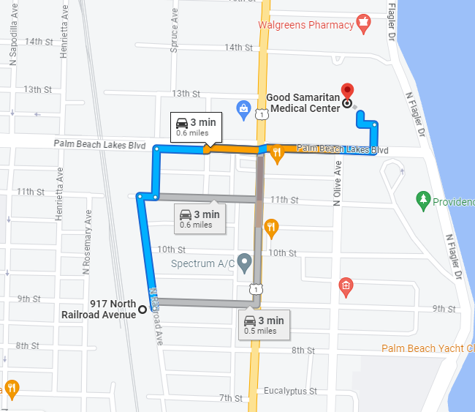

Fire Extinguishers
An appropriately sized ABC dry chemical fire extinguisher shall be conspicuously placed in appropriate areas of the construction project to include (but not limited to):
- On all floors or levels of work.
- Within 75’ of all hot work activities and operations.
- Within 50’ of all flammable liquids.
Fire extinguishers on site shall have the following:
- Annual (current) inspection tag.
- 30-day inspection (documented in HB Trailer).
- Gauge indicating fully charged.
- Pin with security seal.
Note that fire extinguishers to be used by personnel who have been trained to use this equipment.
Emergency Evacuation/Rally Point
If for any reason employees and visitors are required to evacuate the building or site in the event of an emergency, everyone must exit the building safely using one of the three stairwells and proceed to the muster/rally point, which will be immediately to the west of the entrance gates to the site. Everyone should remain there until dismissed. Each subcontractor must account for their personnel and provide names of anyone missing to HB Superintendent, HB PM, fire department Incident Commander, or Police. HB sign in sheet will be consulted as well.
The warning signal to evacuate will be 3 long blasts from an air horn or car horn if necessary.
One long blast from the horn will be the “all-clear” signal that it is safe to reenter the building.

INCIDENT INVESTIGATION AND REPORTING
Emergency incidents should take precedence over all investigations, record keeping and reporting procedures. Ill or injured employees shall be provided the most appropriate medical responses for the incident as soon as possible.
All incidents/accidents will be reported to the Hedrick Brothers Superintendent immediately!
After the ill or injured employee has been provided with the most appropriate first aid or medical care (ambulance, medical facility or on-site first aid), the Hedrick Brothers Superintendent will ensure that incident investigation is initiated in order to correct hazards and prevent re-occurrence.
An incident report, with as much information as possible should be completed within 24 hours. This report is available in the forms section of Procore. Additional information can be added to the report as it becomes available and when the injured or ill employee has returned to work or is capable of providing the necessary information. Incident reports should be forwarded to the Hedrick Brothers Project Manager and Hedrick Brothers Director of Human Resources.
The Competent Person shall correct all identified hazards immediately, an prevent the re-occurrence of the incident and (when necessary) go over the incident and the corrective actions with the project supervisors and /or the employees. A project “stand down” could be warranted to review the incident with everyone on site if the Hedrick Brothers Superintendent finds this warranted.

PERSONAL PROTECTIVE EQUIPMENT
Hedrick Brothers is responsible and will enforce the implementation and use of PPE by employees and subcontractors entering or working on the construction site which may be exposed to a hazardous condition, of if regulations require the use of specified equipment to protect against the hazards of the site.
Each Subcontractor is responsible for doing a Hazard Assessment for his work on this project. During the assessment the Competent Person(s) shall identify potential areas of concern, such as but not limited to;
- Struck by Hazards
- High Temperatures
- Chemical Exposures
- Health Related Hazards
- Sources of non-ionizing radiation such as lasers and radio frequencies
- Falls
- Laceration Hazards
- Electrical Hazards
Employees will be trained on the use, inspection, maintenance, and storage of PPE. No employee shall be required to do PPE for which he/she is not adequately trained.
Minimum PPE required for Hedrick Brothers Construction Site:
- Hard Hat
- Leather Work Shoes/Boots
- Hi-Vis Shirt or Safety Vest
- Shirt with sleeves
- Long Pants
- Eye Protection – as required by task
- Face Shields – as required by task
- Respiratory Protection – as required
- Covid Related Face Covering – as required by CDC or Brevard County
- Hearing Protection – as required by task
- Hand Protection – as required by task

SITE LOGISTICS
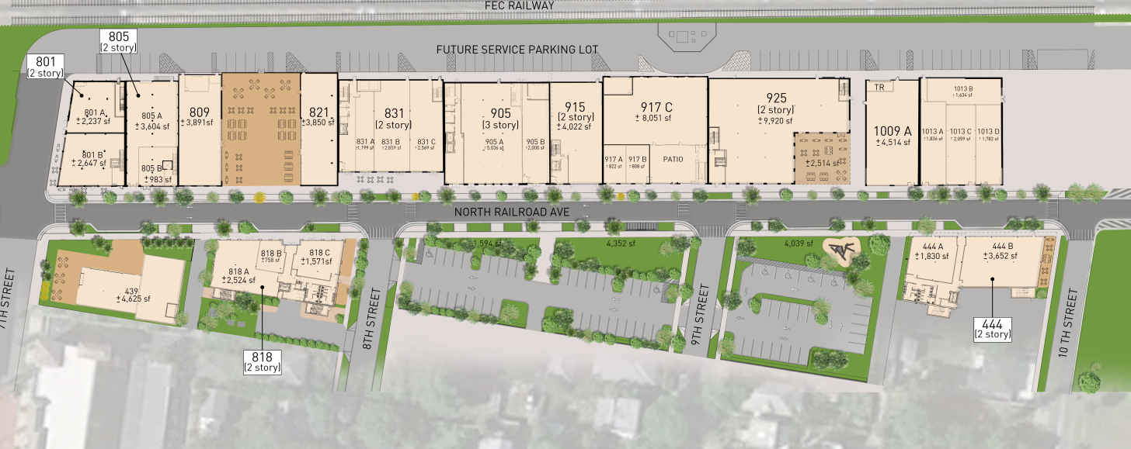

ADDITIONAL BASIC SITE RULES
Hedrick Brothers Superintendent has the authority to direct all personnel on site as he deems appropriate for the progression of the project. Site rules in addition to other sections of this safety plan include:
- This project is a drug and alcohol-free workplace. Anyone discovered onsite under the influence of drugs or alcohol will be removed from the site.
- All persons on site shall be expected to maintain proper personal conduct. There will be zero tolerance of any harassment/violence toward project personnel, visitors to the site, or general public near the site. Violations will result in the immediate and permanent removal from the site of any and all workers involved. This will be at the sole discretion of Hedrick Brothers Superintendent or Project Manager.
- Personnel must park in assigned areas only. Repeated violations could result in removal from the project.
- Lunch and Breaks must be taken in assigned areas per the HB Superintendent.
- No Music/radios are allowed on site. This includes ear buds operating from cell phones. Personnel cannot be distracted on an active site from warning calls/alarms.
- All personnel and visitors to the site must sign in at the Hedrick Brothers Trailer.

HOUSEKEEPING
The competent person is responsible for the housekeeping practices on the site. The aisles, exits and other parts of the means of egress shall be properly maintained and free of unnecessary storage and waste. Sawdust and other combustible materials such as cardboard and paper shall be removed daily to reduce the risk of injury and fire. Trip and fall hazards shall be removed as soon as possible, especially in the areas considered to be walk/work surfaces. Housekeeping practices on this project are extremely important. In order to reduce the risk of fire, prevent injuries and reduce the risk of a regulatory inspection, housekeeping must be maintained, and the following shall be implemented:
- Waste shall be discarded in a suitable container.
- All waste containers inside the building should be emptied at least daily.
- Corridors and other walk/work areas shall not be used for storage.
Trash/Debris to be place in dumpsters (sub provided or HB provided as per contract) daily. Worksite must be cleaned by the end of each day. At the direction of Hedrick Brothers Superintendent, some areas may have to be cleaned immediately and not wait to end of day. Each Subcontractor is responsible for his own debris. If a Subcontractor is found to be lacking in his ability to keep his area clean, Hedrick Brothers Superintendent has the right to use HB labor to clean the area at the Subcontractor’s Expense. This can occur after only one verbal warning.
No storage of any material closer than 6 feet from any floor or hoist way edge.
HAZARD COMMUNICATIONS/GHS/RIGHT-TO-KNOW
All contractors working on this project are required to have written Hazard Communication Program as which incorporates the use of the Globally Harmonized System (OSHA Hazcom Standard). The competent person shall have a binder with all the Safety Data Sheets (SDS) for the products that will be used on the job site. The binder will be inclusive and up to date. An SDS index for each product will be available in order to locate the SDS in a relatively short time. Every Container on site shall be properly labeled (including non-potable water).
The following practices will apply:
- The use of abbreviations or chemical symbols is not permitted. All container contents must be completely spelled out.
- The labels must be suitable for the environment. Containers placed outdoors shall not have labels that fade or deteriorate because of exposure to rain or sunlight.
- Every container shall identify the chemical hazard as well (i.e. corrosive, flammable, reactive or poison/toxic).
- All labels and warnings shall face forward for purposes of inspection and emergency response.
All Subcontractors must submit their SDS sheets to the Hedrick Brothers Superintendent before starting work.

SITE MEETINGS
Subcontractors are required to attend weekly coordination meetings to review site schedule, logistics, safety, permitting issues, procurement issues, submittal reviews, and Requests for Information review.
Subcontractors are required to perform a daily Pre-Task Planning meeting with their workers and the competent person/safety director of their company. Pre-Task Planning Meeting should review hazard assessments for the tasks to be performed each day and how those hazards will be mitigated. Additionally, each subcontractor must perform a weekly safety toolbox talk with their workers and provide Hedrick Brothers Superintendent with a copy of the sign in sheet for this meeting.

HAZARD ASSESSMENT
Hedrick Brothers Superintendent will continually look for hazards on the project site and immediately start the correction procedures with Subcontractors.
Subcontractors must perform the noted daily Pre-Task Hazard Assessments with their work teams to evaluate what hazards they expect to encounter and how they will mitigate that risk. Note that the hazard assessment is a working document and that as issues arise, they should be added to the assessment and the team apprised of the risk mitigation required. Following are basic hazards and do not encompass every hazard that might arise on the project. Hedrick Brothers Comprehensive Safety Manual can be consulted to expand this list and assist with Daily Pre-Task Hazard Assessments.
Electrical Safety
All electrical power is considered to be energized until the responsible electrician or appropriate competent person has verified and tested the system to make sure that it has been de-energized.
Electrical Cords
  - Must be heavy duty 12 gauge with a ground pin
  - No interior flat cords allowed
  - Run cords to prevent tripping hazards, string overhead when possible
  - Immediately remove any damaged cords from service
  - Inspect cords at the end of each day during clean up
  - Must be protected from physical damage
  - Must be properly maintained and stored

Lighting
  - Shall be adequate for the job site
  - Lighting shall be of the appropriate wattage, and placed in fixtures, including temporary usage in a manner specified by the lighting manufacturer
  - Emergency lighting is required if work on the project will extend to after daylight hours
Power Tools
  - Portable electrical equipment and tools must be grounded or double insulated.
  - Power tools should be inspected at the start of each shift. Check for frayed cords.
  - Power tools should have all guards in place.
  - Any power tool removed from service, because of damage, shall be labeled out of service by the person(s) who discover the deficiency.
Ground Fault Circuit Interrupters (GFCI)
GFCI protected equipment and tools can be accomplished by one of the following:
  - A GFCI outlet
  - An outlet protected by a GFCI breaker
  - A portable GFCI pigtail
GFCI protection for all power tools and flexible cords is required for the duration of the project. When permanent wiring for the building/project or site has been completed, GFCI protection shall still be required. All contractors shall either obtain power from a permanently wired GFCI outlet or a GFCI adapter/pigtail between the power supply and the flexible cord or tool being used.

Fall Protection
In accordance with the requirements of Federal, State, and local standards, all employers are required to provide fall protection equipment and training to their employees when they are working at elevations above a lower level which meet or exceed the fall protection threshold heights stated in such standards. The competent person for fall protection on this project is responsible for identifying fall protection hazards and implementing controls to mitigate the fall hazards for exposed employees.
Each subcontractor working at heights is required to submit their fall protection plan to the Hedrick Brothers Superintendent for review prior to starting work.

Hot Work
Brazing, cutting, heating, soldering, welding, and other spark or flame producing work on this job requires that the competent person:
  - Inspect the area where the work is to be performed.
  - Ensure any and all combustible materials shall be located at least 35’ away from the Hot Work Area.
  - Ensure fire extinguishers are located within 25’ of the Hot Work Area and that they are of proper size and type for the activity.
  - If sparks or debris could expose people and material at a lower floor, then a fire watch should be posted, and the area taped off with Red Danger Tape.
  - Inspect area after work is concluded to look for smoldering debris that could result in a fire at a later time.
Ladders and Stairways
Ladders shall be a minimum of Type 1 (heavy duty rated) unless otherwise authorized. All ladders shall be inspected before use and shall be removed from service if damaged, broken, or unsafe. Ladders shall be used in accordance with the Federal, State, or local standards (applying the most stringent standard). The following applies to all ladders:
  - Damaged ladders shall be tagged “out of service – DO NOT USE” if they are found to be defective or damaged in any way (report out of service ladders to the Hedrick Brothers Superintendent immediately.
  - Aluminum ladders are not to be used.
  - Ladders shall not be painted or covered in a manner that will cover up cracks and other defects.
  - Ladders shall have all of the appropriate warning and danger labels in place, maintained in a legible condition.
Extension Ladders
  - Shall be pitched at the required 4:1 ratio.
  - Shall be tied or otherwise secured to the structure or elevated surface to prevent tipping or falling. (Secured top and bottom)
  - Shall be extended at least 3 rungs or 36” above the elevated work surface.
  - Shall be inspected daily and before each use.

Step Ladders
  - Shall be opened completely with spreaders locked in place.
  - Shall not be used as straight ladders.
  - Shall be tall enough to perform the necessary work.
  - The top two steps of a step ladder shall not be used for standing.
  - Shall not be used on scaffolding or next to guardrails unless the height of the guardrails has been adjusted or alternate fall protection is provided.
Aerial Lifts/Scissor Lifts
Personnel lifts such as articulating booms, single person upright lifts (Genie, JLG and Uprights) and scissor lifts shall be used in a manner specified by the manufacturer, in accordance with the requirements of OSHA 29 CFR 1910.66 and any other applicable Federal, State, local or manufacturer specific standards.
Any employee operating or working from an articulating boom lift is required to be equipped with a personal fall protection equipment system consisting of an approved full body harness and lanyards and must have receive training on how to operate the equipment and how to properly wear the fall protection system.
Subcontractors must submit training certificates on all personnel that will operate equipment before work has commenced.
Personnel lifts shall be inspected before each use, and must be removed from service if a deficiency is noted. The following shall apply to aerial lift inspections:
  - All safety devices and related equipment shall be tested as part of the inspection for proper operation.
  - The lift if damaged or otherwise impaired shall be tagged “out of service” to prevent use until repaired.
All lifts shall bear the following manuals and warnings in legible condition:
  - The operator’s manual shall be located on the lift at all times, for ease of reference.
  - All Danger and Warning stickers shall be attached to the lift and shall be in legible condition.
Verify load limits of platforms and that they are not being exceeded. Lift should be used for personnel and tools, not for material transport or installation.
Personnel who utilize one of the lifts referenced above can use such lifts to access a higher-level platform, provided that the lift can be set on top of the elevated surface allowing the lift operator to exit the swing gate of the lift instead of climbing over the guardrails. Note: employees existing lifts onto an elevated surface must ensure that they are connected to a fall protection system before existing the aerial lift equipment.
Operators are not permitted to stand on the rails of a lift unless they are attached to a higher structure with a lanyard and a full body harness. If it is absolutely necessary to step from a lift to an elevated surface that they cannot set the lift on top of the surface, then a two-lanyard system must be used for 100% fall protection.
Do Not Exit an Aerial Lift Unprotected!
Silica Exposure
Personnel must be trained on silica exposure and the required control steps depending on exposure. OSHA Silica Table 1 Should be consulted for Specified Exposure Control Methods When Working with Materials Containing Silica. If the control methods per Table 1 cannot be fully implemented, then Alternate Exposure Control Methods must be used such as dust controls and respirators. The Subcontractor is required to provide their workers with all materials/equipment to minimize exposure. Subcontractors that will be working with Silica containing substrates must include a Written Exposure Control Plan as part of their SSSP.
Respiratory Protection
Personnel must be on respiratory hazards. Any employee wearing respiratory protection must be medically evaluated and fit tested. Respiratory selection must be chosen by obtaining information from the safety data sheets supplied by the manufacturer. The Subcontractor is required to provide their workers with all materials/equipment to minimize exposure. Subcontractors that will be working with Silica containing substrates must include a Written Exposure Control Plan as part of their SSSP.

Lightning Procedures
Superintendents are to ensure protection from Lightning exposure by:
- Observing weather reports daily for the possibility of storms entering the area.
- Once thunder is heard, utilize the 30-30 rule of measuring 30 seconds time lapse from the time lightning is observed to time thunder is heard.
- Once this threshold is crossed all construction activities cease and personnel must seek shelter.
- Personnel must remain sheltered until 30 minutes after the storm has passed. Weather apps can also be used to help ascertain safe conditions.
This process will include an emergency horn (3 blasts) to let all workers know to rally at the jobsite trailer or seek shelter. 1 horn blast is the all clear sign to return to work.

Safety Manuals
Hedrick Brothers Comprehensive Safety Manual is available from the Hedrick Brothers Superintendent or Project Manager.
Each Subcontractor is responsible for supplying their company’s Safety Manual to the Hedrick Brothers Superintendent.

PLAN REVIEW/APPROVAL

Hedrick Brothers Superintendent: _________________________________________________
Date: _______________________

Hedrick Brothers Project Manager: ________________________________________________
Date: ________________________

Hedrick Brothers Safety Officer: ___________________________________________________
Date: ______________________

